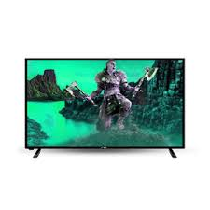

***Pel 9160LF led***

* **Color:**Black
* **Available:**in stock
* **Dimension:**1641*595*600
* **Size:**55
* **Old Price:**~~Rs 40,000~~
* **New Price:**Rs 34,000 (5%)